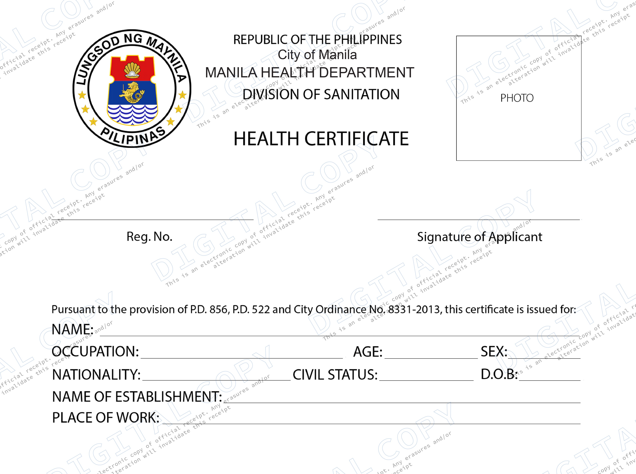

MERCHANDISER



M-080884

MECAILLA DOCTORA CASTUERA

FOOD HANDLER

36

y/o

FEMALE

FILIPINO

SINGLE

Jun 17, 1986

SM Supermarket

1986

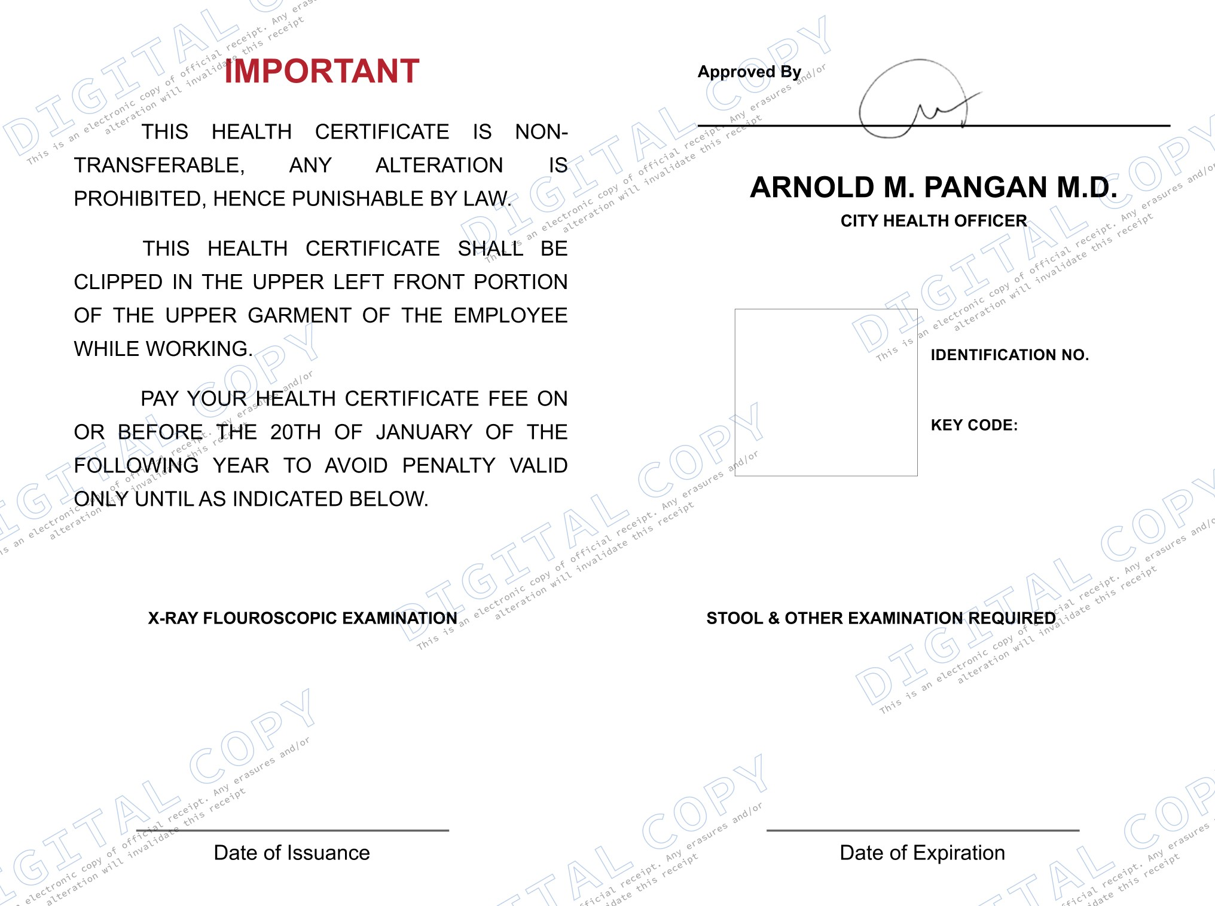

NEGATIVE

NEGATIVE

**DRUG TEST**

NEGATIVE

September 27, 2022

September 27, 2023